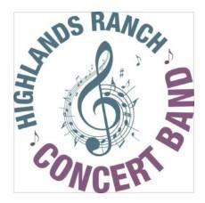 |  |  | 2024 Highlands Ranch Concert  Band/Swing Shift  Summer - Fall  Schedule |  |  | 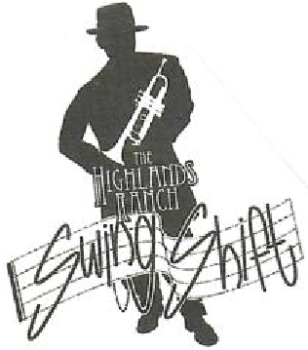
Day | Date | Time | Group | Time | Group | Location
Wednesday | 8/14/2024 | 6:30 PM - 7:30 PM | Swing Shift | 7:45 PM - 9:15 PM | Concert Band | Cresthill Middle School
Wednesday | 8/21/2024 | 6:30 PM - 7:30 PM | Swing Shift | 7:45 PM - 9:15 PM | Concert Band | Cresthill Middle School
Wednesday | 8/28/2024 | 6:30 PM - 7:30 PM | Swing Shift | 7:45 PM - 9:15 PM | Concert Band | Cresthill Middle School
Wednesday | 9/4/2024 | 6:30 PM - 7:30 PM | Swing Shift | 7:45 PM - 9:15 PM | Concert Band | Cresthill Middle School
Wednesday | 9/11/2024 | 6:30 PM - 7:30 PM | Swing Shift | 7:45 PM - 9:15 PM | Concert Band | Cresthill Middle School
Wednesday | 9/25/2024 | 6:30 PM - 7:30 PM | Swing Shift | 7:45 PM - 9:15 PM | Concert Band | Cresthill Middle School
Wednesday | 10/2/2024 | 6:30 PM - 7:30 PM | Swing Shift | 7:45 PM - 9:15 PM | Concert Band | Cresthill Middle School
Wednesday | 10/23/2024 | 6:30 PM - 7:30 PM | Swing Shift | 7:45 PM - 9:15 PM | Concert Band | Cresthill Middle School
Wednesday | 10/30/2024 | 6:30 PM - 7:30 PM | Swing Shift | 7:45 PM - 9:15 PM | Concert Band | Cresthill Middle School
Wednesday | 11/6/2024 | 6:30 PM - 7:30 PM | Swing Shift | 7:45 PM - 9:15 PM | Concert Band | Cresthill Middle School
Wednesday | 11/13/2024 | 6:30 PM - 7:30 PM | Swing Shift | 7:45 PM - 9:15 PM | Concert Band | Cresthill Middle School
Wednesday | 11/20/2024 | 6:30 PM - 7:30 PM | Swing Shift | 7:45 PM - 9:15 PM | Concert Band | Cresthill Middle School
Wednesday | 12/4/2024 | 6:30 PM - 7:30 PM | Swing Shift | 7:45 PM - 9:15 PM | Concert Band | Cresthill Middle School
Sunday | 10/6/2024 |  |  | 3:00 PM Concert | Concert Band | w/Rocky Mtn Brass  Mountainview Christian Church
Monday | 11/11/2024 |  |  | 6:30PM – 7:30 PM | Veteran’s Day Concert  Ensemble 40 Players | Highlands Ranch Library
Sunday | 12/8/2024 |  |  | 3:00 PM | Holiday Concert w/Newton Middle School 8th Grade Band | Aspen Academy Greenwood Village

